**6.C85 Vis and Society**

Submission by: Rita Uganden-Teryila

**Visualizations**



### **Tabular Visualization:**

* A table allows for a clear comparison of different attributes, such as census years (1900 vs. 2000), making it easier to identify trends and differences.
* Presenting data in tabular form helps conceptualize orders of magnitude, highlighting the scale of demographic changes over time.
* Enables the generation of new insights, such as aggregating male and female populations to determine the total within a given demographic category.

1. **Trendlines:**

* 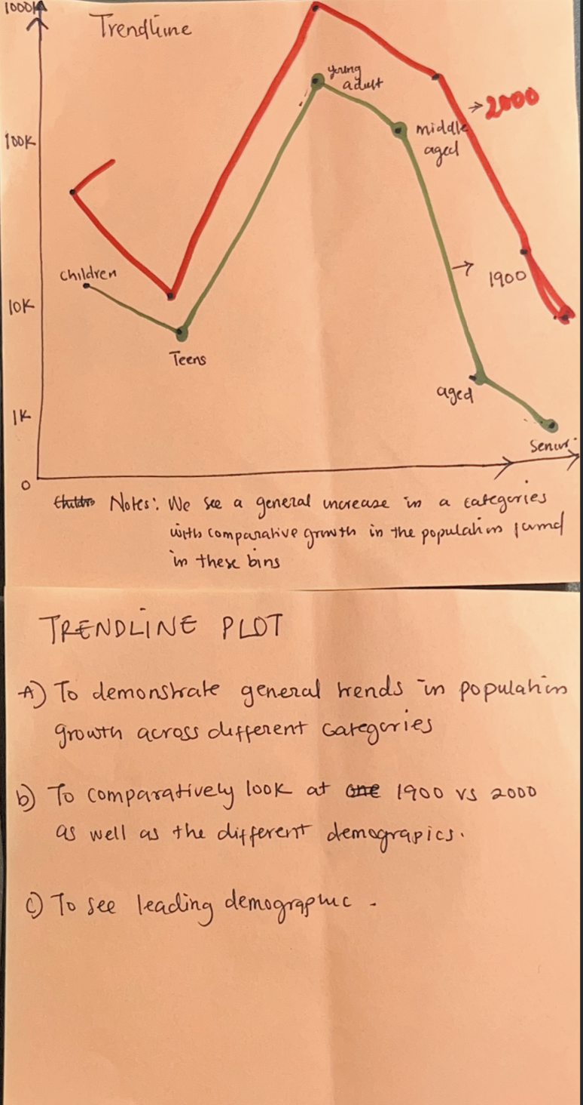Trendlines help illustrate general population growth trends across different demographics, making patterns more apparent over time.
* They allow for a direct comparison between census years (e.g., 1900 vs. 2000) and demographic distributions within these years.
* **Identifying Leading & Lagging Demographics** trendlines highlight which demographics are growing the fastest and which are experiencing slower growth or decline.

1. 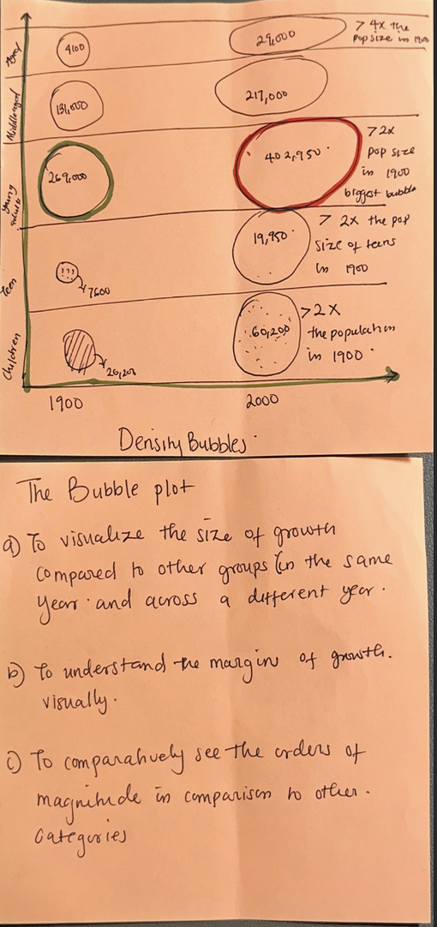 **Bubble Plot:**

* Helps compare the size of demographic growth within the same year and across different years by using bubble sizes to represent population changes.
* Clearly shows the extent of growth or decline for each demographic, making it easier to spot significant shifts.
* Enables a comparative analysis of population sizes across demographics and years, emphasizing differences in scale

**Reflection**

Each of the three visualizations—tables, trendlines, and bubble plots—has unique strengths and weaknesses for analyzing demographic changes. Tabular visualizations provide precise numerical comparisons, making them ideal for detailed data analysis; however, they are less effective for quickly identifying patterns. Trendlines excel at illustrating growth trends over time and highlight leading and lagging demographics, though they may oversimplify categorical differences. On the other hand, bubble plots offer an intuitive way to compare population sizes and growth margins visually, but they can become cluttered if too many data points overlap. In the future, I may consider a A hybrid visualization that combines trendlines and bubble plots to provide deeper insights. Trendlines effectively capture growth patterns over time, while bubble plots intuitively show the magnitude of demographic shifts. By overlaying bubbles on a trendline graph (for example, using bubble size to represent population counts at different points in time), I could highlight both trends and scale simultaneously. This approach would offer historical context through the trendline and relative magnitude comparisons via the bubbles. Additionally, I might integrate a small table for reference to ensure numerical precision without overwhelming the visual representation. Would you like me to draft an example of how this could look?